Department of Mathematics

School of Advanced Sciences

MAT 1011 – Calculus for Engineers (MATLAB)

Experiment 3-A

Plotting 3D curves and surfaces, Taylor series of function of two variables

Prepared by: Bimal parajuli

Registration Number: 20BDS0405

**Question 1:**

**Draw the surface of the function f(x,y)=e^x+e^y using ezsurf.**

**CODES:**

clear

clc

syms x y

f=2*(exp(x)+exp(y));

ezsurf(f)

colormap cool

**OUTPUT:**

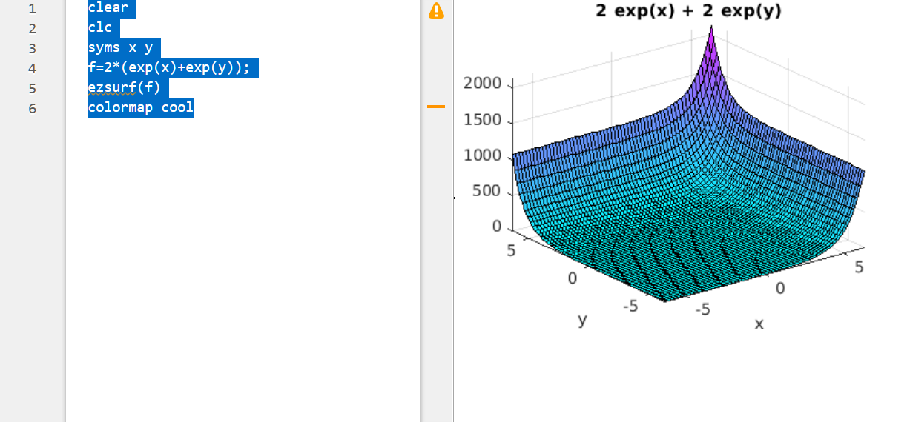

**Question 2:**

**Draw the 3D-plot of the function f(t)=(t,t^2,t^3), where** 

**CODES:**

clear

close all

clc

syms t

x=t;

y=t^2;

z=t^3;

ezplot3(x,y,z,[0,100])

**OUTPUT:**

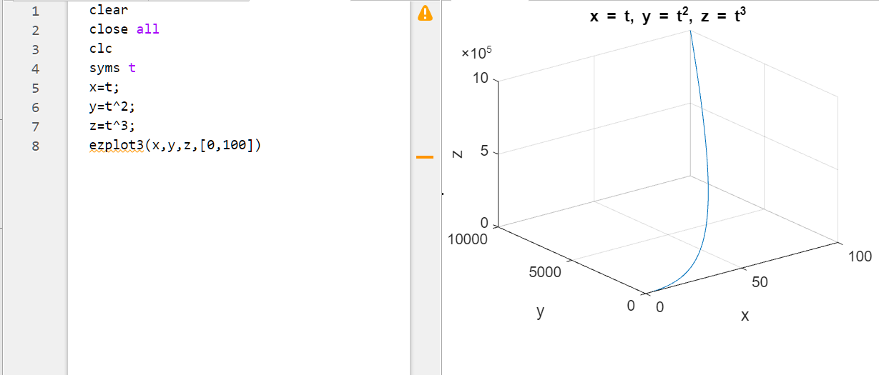

**Question 3:**

**Using surf, plot the surface of**



**CODES:**

clear

close all

clc

syms x y;

[x,y]=meshgrid(-3:0.2:3);

z = ((x.^3) + x .* (y.^2));

surf(x,y,z)

**OUTPUT:** 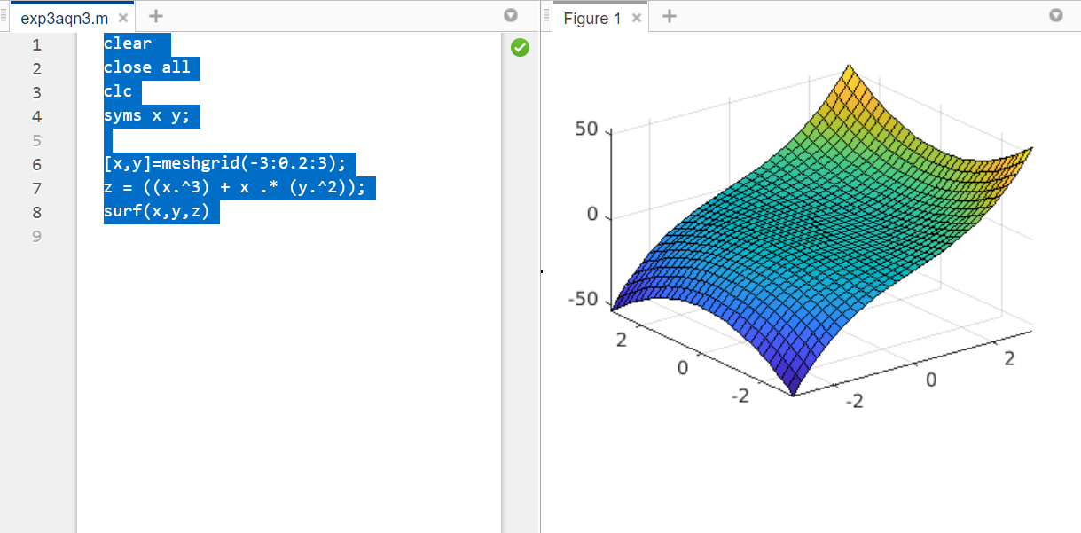

**Question 4:**

**Expand  in terms of x and y upto the terms of 3rd degree using Taylor series.**

**CODES:**

clear

close all

clc

syms x y;

f=input('Enter the function to be approximated');

Neighbourhood=input('Enter the points[a,b] of approximation');

a=Neighbourhood(1);

b=Neighbourhood(2);

n=input('Enter the order for approximation');

expansion=taylor(f,[x,y],[a,b],'order',n);

disp('The Taylors expansion of the given function is:')

disp(expansion)

subplot(1,2,1);

ezsurf(f);

subplot(1,2,2);

ezsurf(expansion);

**INPUT:**

Enter the function to be approximated

exp(x)*log(1+y)

Enter the points[a,b] of approximation

[0,0]

Enter the order for approximation

3

**OUTPUT:**

The Taylors expansion of the given function is:  
y + x*y - y^2/2

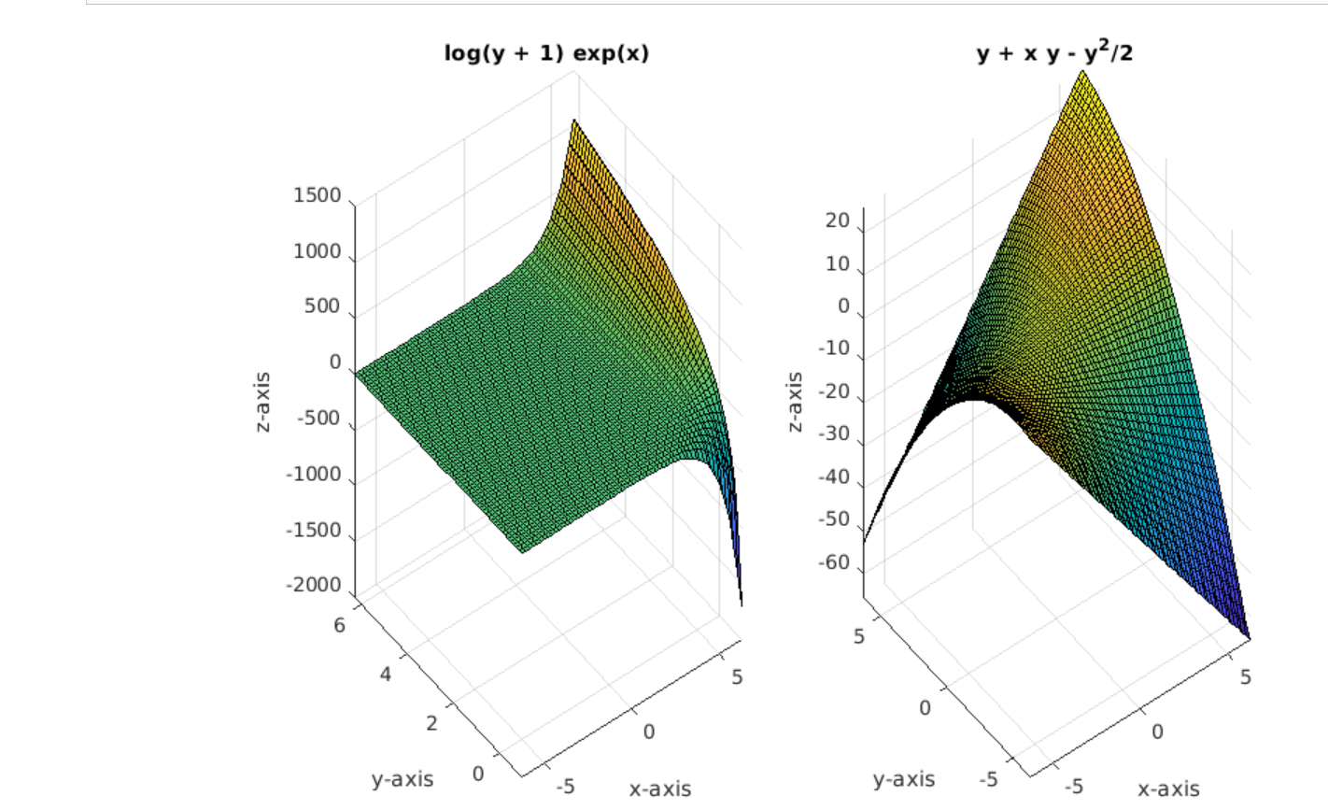

**Question 5:**

**Expand  in Taylor series the neighbouhood of (1,1).**

**CODE:**

clear all

close all

clc

syms x y;

f=exp(y*x);

neighbourhood=[1,1];

a=neighbourhood(1)

b=neighbourhood(2)

n=input('Enter the order of expansion');

expan=taylor(f,[x,y],[a,b],'order',n);

disp('The taylors expansion about the point is ')

disp(expan)

subplot(1,2,1)

ezsurf(expan);

subplot(1,2,2)

ezsurf(f);

**INPUT**

a =  
  
 1  
  
  
b =  
  
 1  
  
Enter the order of expansion

3

**OUTPUT:**

The taylors expansion about the point is   
exp(1) + exp(1)*(x - 1) + exp(1)*(y - 1) + (exp(1)*(x - 1)^2)/2 + (exp(1)*(y - 1)^2)/2 + 2*exp(1)*(x - 1)*(y - 1)

